**Requirement Gathering and Analysis Phase**

**Data Flow Diagram & User Stories**

|  |  |
| --- | --- |
| Date |  |
| Team ID | SWTID1720195916 |
| Project Name | Stock Trading Web App |
| Maximum Marks |  |

**Data Flow Diagrams:**

A Data Flow Diagram (DFD) is a traditional visual representation of the information flows within a system. A neat and clear DFD can depict the right amount of the system requirement graphically. It shows how data enters and leaves the system, what changes the information, and where data is stored.

**Stock Trading Web App DFDs:**

**Level-0 Description:**

User: The end-user who interacts with the stock trading web app.

Process Trade: Handles trade requests from the user, processes them, and updates the stock data and user data.

Fetch Stock Data: Requests and retrieves real-time stock data from the Stock Market Data API and updates the stock data in the database.

Notify User: Sends notifications to the user regarding their trades or stock updates.

Stock Data: Database storing stock information.

User Data: Database storing user information.

Stock Market Data API: External service providing real-time stock market data.

Notification Service: External service used to send notifications to the user.

**Level-1 Description and Processes:**

User: The end-user who interacts with the stock trading web app.

Stock Data: Database storing stock information.

User Data: Database storing user information.

Stock Market Data API: External service providing real-time stock market data.

Notification Service: External service used to send notifications to the user.

**Processes:**

User Interface (UI): Manages user requests and interactions with the web app.

User Authentication (Auth): Handles login and signup processes, updates user data.

Trade Processor: Manages trade requests, updates stock data, and communicates with the portfolio manager and notifier.

Portfolio Manager: Updates user portfolios based on trade activities.

Data Fetcher: Requests real-time stock data from the Stock Market Data API and updates the stock data.

Notifier: Sends notifications to users through the Notification Service.

**Level – 0 DFD**

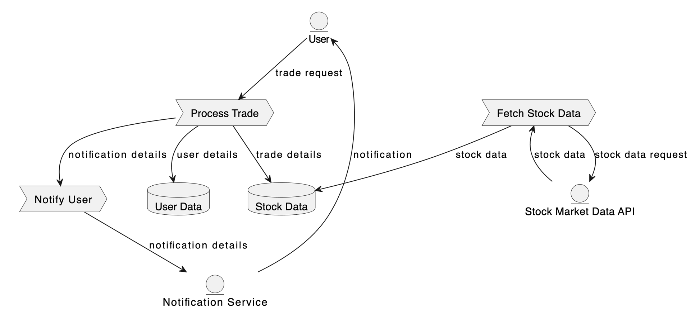

**Level – 1 DFD**

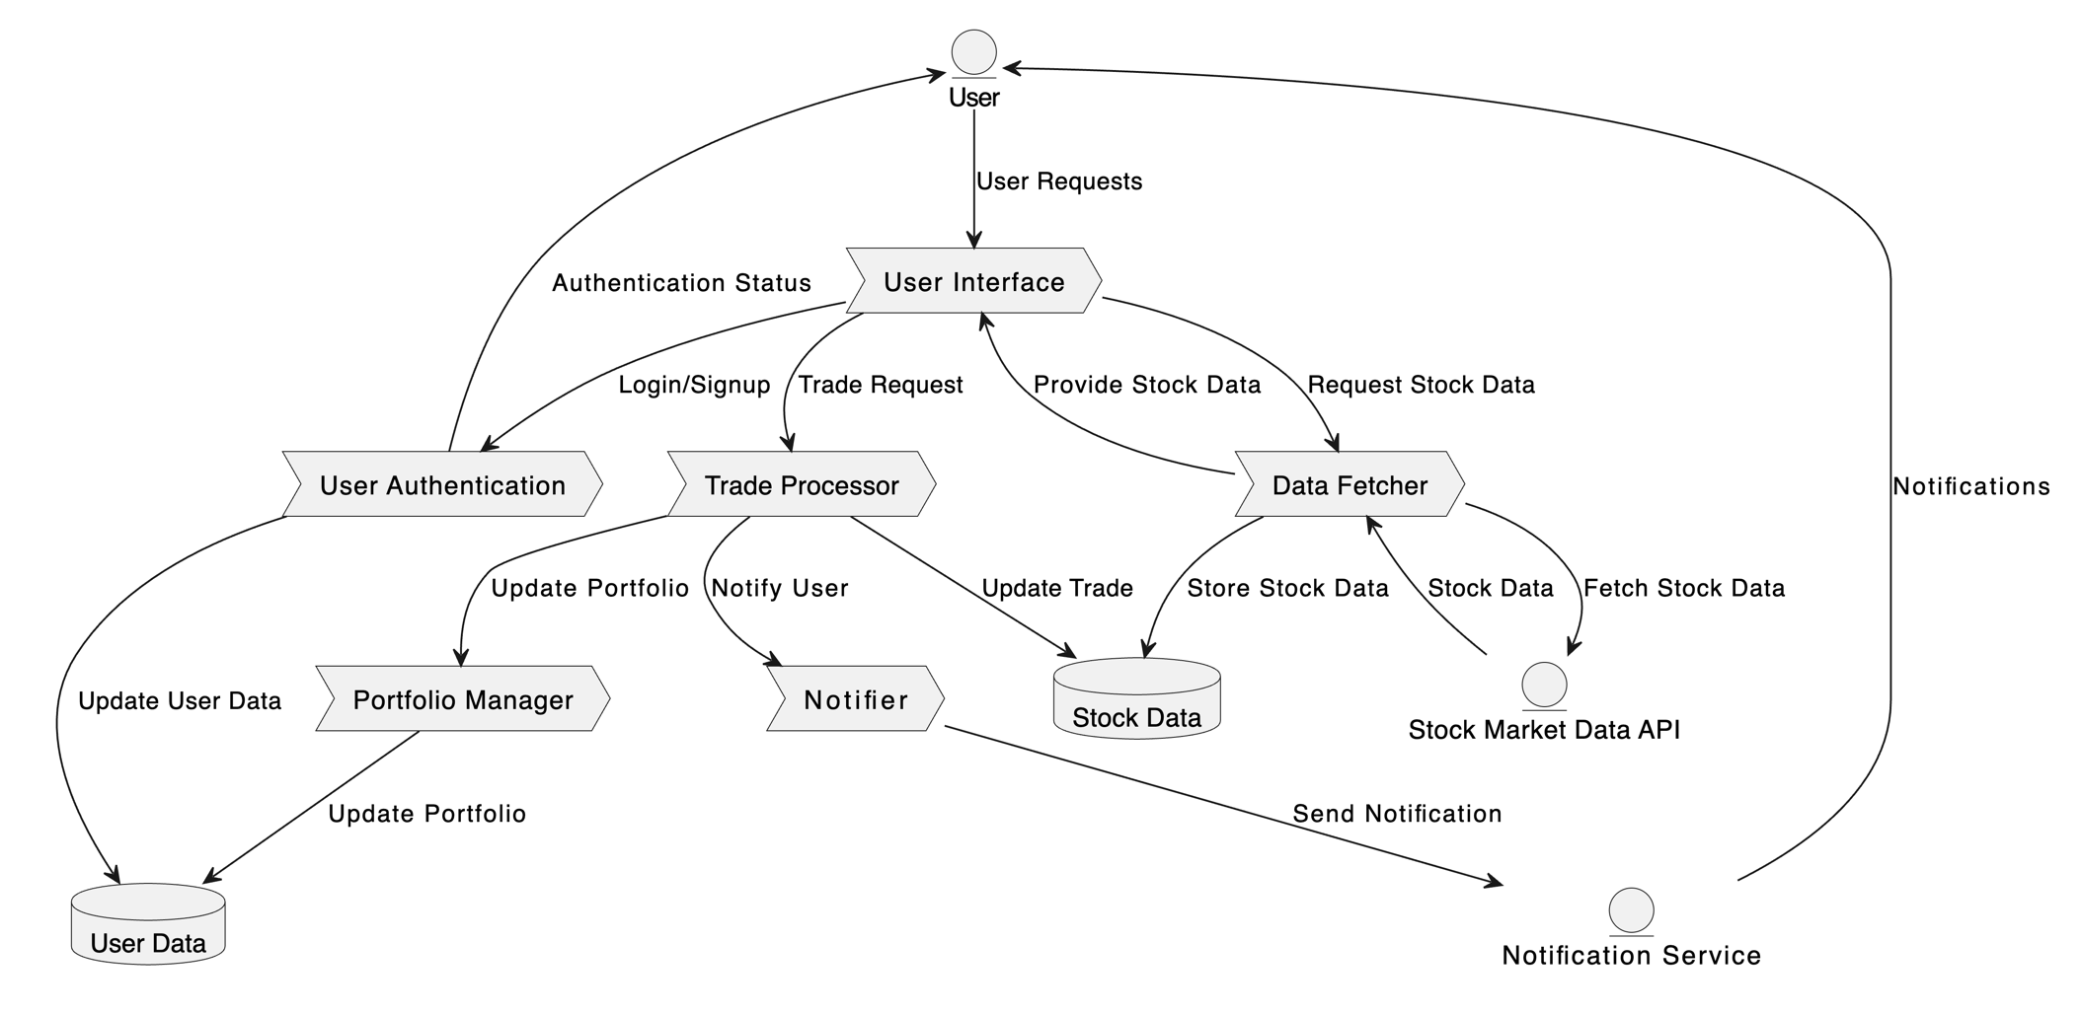

**User Stories**

Use the below template to list all the user stories for the product.

| **User Type** | **Functional Requirement (Epic)** | **User Story Number** | **User Story / Task** | **Acceptance Criteria** | **Priority** | **Release** |
| --- | --- | --- | --- | --- | --- | --- |
| Customer (Web user) | Account Management | USM-1 | As a user, I want to create an account to start trading. | I can provide personal information, set a username and password, and agree to terms of service. | High | Sprint 1 |
| Customer (Web user) | Account Management | USM-2 | As a user, I want to log in to my existing account. | I can enter my credentials (username/email and password) and access my account dashboard. | High | Sprint 1 |
| Customer (Web user) | Account Management | USM-3 | As a user, I want to securely reset my password. | I can request a password reset link via email and successfully change my password. | Medium | Sprint 2 |
| Customer (Web user) | Market Data | USM-4 | As a user, I want to view real-time stock quotes and market data. | I can see up-to-date stock prices, trading volume, and market indices. | High | Sprint 1 |
| Customer (Web user) | Market Data | USM-5 | As a user, I want to search for stocks by ticker symbol or company name. | I can quickly find relevant stocks and view their details. | Medium | Sprint 1 |
| Customer (Web user) | Trading | USM-6 | As a user, I want to place buy and sell orders for stocks. | I can specify the stock, quantity, price, and order type (market, limit, stop). | High | Sprint 2 |
| Customer (Web user) | Trading | USM-7 | As a user, I want to view my order history and trade confirmations. | I can see a detailed history of my past orders and their execution status. | Medium | Sprint 2 |
| Customer (Web user) | Portfolio Management | USM-8 | As a user, I want to track my stock portfolio and its performance. | I can see a list of my owned stocks, their current value, and overall portfolio gain/loss. | High | Sprint 2 |
| Customer (Web user) | Portfolio Management | USM-9 | As a user, I want to set up watchlists to monitor specific stocks. | I can create custom watchlists and add/remove stocks as needed. | Medium | Sprint 3 |
| Customer (Web user) | Research | USM-10 | As a user, I want to access stock research and analysis. | I can view analyst ratings, company financials, and news articles related to stocks. | Medium | Sprint 3 |
| Customer (Web user) | Customer Support | USM-11 | As a user, I want to contact customer support for assistance. | I can submit a support ticket or access a knowledge base for troubleshooting. | Low | Sprint 4 |
| User Type | Functional Requirement (Epic) | User Story Number | User Story / Task | Acceptance Criteria | Priority | Release |